Determining Areas of Influence –
CenSARA Round Two Regional Haze

Final Report

Prepared for:
Michael Vince
Central States Air Resource Agencies Association (CenSARA)

Prepared by:
Uarporn Nopmongcol, Ross Beardsley,
Jeremiah Johnson, and Susan Kemball-Cook
Ramboll
7250 Redwood Blvd, Suite 105 Novato, CA 94945
www.ramboll.com
P-415-899-0700
F-415-899-0707

November 2018

CONTENTS
1.0 INTRODUCTION 1
2.0 Approach 2
2.1 Data Sources 2
2.1.1 IMPROVE Data 2
2.1.2 Emission Data 3
2.2 Back-Trajectory Modeling 4
2.3 Area of Influence Analysis 5
2.3.1 Residence Time Analysis 5
2.3.2 Distance-weighted Analysis 5
2.3.3 Extinction Weighted Residence Time 5
2.3.4 EWRT Plot Combined with Distance-Weighted Emissions 6
2.4 Point Source Emissions Contributions 7
3.0 Graphic products 8
4.0 Summary and Recommendations 15
4.1 Deliverables 15
4.2 Uncertainties and limitations 15
4.3 Recommendations 16
5.0 References 17

TABLES
Table 2-1. Class I Areas of Interest. 2

FIGURES
Figure 2-1. Annual point source NO_{x} emissions for the CenSARA for 2016 and 2028 in tons/year. 6
Figure 2-2. Annual point source SO₂ emissions for the CenSARA for 2016 and 2028 in tons/year. 7
Figure 3-1. Example residence time plot for 20% worst visibility days in 2012-2016 for Caney Creek based on trajectories with 100-m, 200-m, 500-m, and 1,000-m end height. 9
Figure 3-2. Example distance-weighted residence time plot for 20% worst visibility days in 2012-2016 for Caney Creek based on trajectories with 100-m, 200-m, 500-m, and 1,000-m end height. 10
Figure 3-3. Example sulfate extinction-weighted residence time (EWRT) plot for 20% worst visibility days in 2012-2016 for Caney Creek based on trajectories with 100-m, 200-m, 500-m, and 1,000-m end height. 11
Figure 3-4. Example nitrate extinction-weighted residence time (EWRT) plot for 20% worst visibility days in 2012-2016 for Caney Creek based on trajectories with 100-m, 200-m, 500-m, and 1,000-m end height. 12
Figure 3-5. Example sulfate EWRT combined with distance-weighted (SO₂) emissions (2016 on the left and 2028 on the right) plot for 20% worst visibility days in 2012-2016 for Caney Creek based on trajectories with 100-m (top) and 500-m (bottom) end height. Contour boundaries based on the sulfate EWRT greater than 0.1% (lighter green) or 0.5% (darker green) are also shown. 13
Figure 3-6. Example nitrate EWRT combined with distance-weighted (NO_{x}) emissions (2016 on the left and 2028 on the right) plot for 20% worst visibility days in 2012-2016 for Caney Creek based on trajectories with 100-m (top) and 500-m (bottom) end height. Contour boundaries based on the nitrate EWRT greater than 0.1% (lighter green) or 0.5% (darker green) are also shown. 14

INTRODUCTION
Regional haze, as defined in the Regional Haze Rule at 40 CFR 51.300, is “visibility impairment that is caused by the emission of air pollutants from numerous sources located over a wide geographic area. Such sources include, but are not limited to, major and minor stationary sources, mobile sources, and area sources”. The Regional Haze Rule required states to submit initial state implementation plans (SIPs) to the US Environmental Protection Agency (EPA) by December 2007. SIPs contain enforceable measures for reducing concentrations of pollutants that cause visibility impairment including fine particulate matter (PM_{2.5}), and PM_{2.5} precursors such as oxides of nitrogen (NOx), sulfur dioxides (SOx), and volatile organic compounds (VOC). The second phase (Round 2) SIPs are due in July 2021.
A primary step in developing the SIPs is to characterize the sources that lead to visibility impairment at Class I areas. Back-trajectory receptor models are useful tools for identifying potential regional source locations impacting visibility and have been used to facilitate regional haze planning. This project used a back-trajectory model together with air quality measurement data and emission inventories to identify the geographic areas and emission sources with a high probability of contributing to anthropogenically impaired visibility at Class I areas within CenSARA and nearby states.
The purpose of this work is to identify the geographic areas and emission sources with a high probability of contributing to anthropogenically impaired visibility at CenSARA Class I areas. Ramboll carried out residence time analysis using back-trajectory modeling and extended the analysis using emission, visibility extinction, and distance weighting approach.
This report summarizes our approach and provides examples of graphical results developed in this work. Section 2 of this report describes data sources and our approach. Section 3 presents examples of residence time graphics. We provide additional graphics separately to accompany this report. Summary and recommendations are provided in Section 4.

Approach

Data Sources

IMPROVE Data
The latest Regional Haze Rule Summary Data daily impairment values include daily IMPROVE PM_{2.5} components and coarse PM concentration measurements, light extinction values, and visibility impairment parameters. The data flag the 20% most anthropogenically impaired days during the 5-year period from 2012 to 2016. The data include “patched” values (historical seasonal median values are used to fill in missing values following procedures described in EPA’s Guidance for Tracking Progress Under Regional Haze Rule) so that data were available for each day of the 2012-2016 period of this study. Daily impairment data were downloaded from the IMPROVE website.
Table 2-1 lists the Class I Areas included in the analysis.
Table 2-1. Class I Areas of Interest.
IMPROVE Site (FLM) | IMPROVE Site Code | State | Latitude | Longitude | Operation Dates
Big Bend N.P. (NPS) | BIBE1 | TX | 29.3027 | -103.178 | 3/1988 - Present
Guadalupe Mountains N.P. (NPS) | GUMO1 | TX | 31.833 | -104.8094 | 3/1988 - Present
Wichita Mountains Wilderness (FWS) | WIMO1 | OK | 34.7323 | -98.713 | 3/2001 - Present
Caney Creek Wilderness Area (FS) | CACR1 | AR | 34.4544 | -94.1429 | 6/2000 - Present
Upper Buffalo Wilderness Area (FS) | UPBU1 | AR | 35.8258 | -93.203 | 12/1991 - Present
Breton Wilderness Area (FWS) | BRIS1 | LA | 30.1086 | -89.7617 | 1/2008 - Present
Hercules-Glades Wilderness Area (FS) | HEGL1 | MO | 36.6138 | -92.9221 | 3/2001 - Present
Mingo Wilderness Area (FWS) | MING1 | MO | 36.9717 | -90.1432 | 5/2000 - Present
Great Sand Dunes Wilderness Area (NPS) | GRSA1 | CO | 37.7249 | -105.5185 | 5/1988 - Present
Rocky Mountain National Park (NPS) | ROMO1 | CO | 40.2783 | -105.5457 | 9/1990 - Present
Salt Creek Wilderness Area (FWS) | SACR1 | NM | 33.4598 | -104.4042 | 4/2000 - Present
White Mountain Wilderness Area (FS) | WHIT1 | NM | 33.4687 | -105.5349 | 1/2002 - Present
Wheeler Peak Wilderness Area (FS) | WHPE1 | NM | 36.5854 | -105.452 | 8/2000 - Present
Voyageurs NP #2 (NPS) | VOYA2 | MN | 48.4126 | -92.8286 | 11/1999 - Present
Boundary Waters Canoe Area (FS) | BOWA1 | MN | 47.9466 | -91.4955 | 8/1991 - Present
Seney (FWS) | SENE1 | MI | 46.2889 | -85.9503 | 11/1999 - Present
Isle Royale (NPS) | ISLE1 | MI | 47.4596 | -88.1491 | 11/1999 - Present
Mammoth Cave NP (NPS) | MACA1 | KY | 37.1318 | -86.1479 | 9/1991 - Present
Sipsey Wilderness (FS) | SIPS1 | AL | 34.3433 | -87.3388 | 3/1992 - Present
Wind Cave (NPS) | WICA1 | SD | 43.5576 | -103.4838 | 12/1999 - Present
Badlands NP (NPS) | BADL1 | SD | 43.7435 | -101.9412 | 3/1988 - Present
Theodore Roosevelt (NPS) | THRO1 | ND | 46.8948 | -103.3777 | 12/1999 - Present
Lostwood (FWS) | LOST1 | ND | 48.6419 | -102.4022 | 12/1999 - Present

Emission Data
For this study, we used 2016 and 2028 emission inventory data to determine the potential impact from sources of SO₂ and NOx emissions (precursors of sulfate [SO₄] and nitrate [NO₃], respectively). Industrial sources, including electric generating unit (EGU) and other industrial point (non-EGU) sources, are major contributors to both SO₂ and NOx emissions. Industrial emissions released at elevated stack heights can potentially be transported very far downwind impacting visibility in the Class I areas. We analyzed potential visibility impacts from EGU and non-EGU sources.
The EPA’s National Emissions Inventories (NEI) are comprehensive and detailed estimate of air emissions of criteria pollutants, criteria precursors, and hazardous air pollutants from air emissions sources. The NEIs are generated using EPA approved methods and are publicly available. These inventories have been used in determining compliance with the NAAQS and for policy development and community planning. The 2011v6.3 modeling platform is based on the 2011NEI version 2 and includes projected future years of 2017, 2023, and 2028. There are multiple modeling cases available through the 2011NEI platform. These modeling cases are indexed alphabetically beginning with a as EPA introduces emission updates. The modeling cases 2011ek and 2017ek supported the Final Cross-State Air Pollution Rule (CSAPR) Update, a rule related to interstate transport for the 2008 Ozone National Ambient Air Quality Standards (NAAQS). Updates to the platform were made to support preliminary modeling of interstate transport for the 2015 Ozone NAAQS with cases 2011el and 2023el, and preliminary modeling for the assessment of reasonable progress for regional haze with cases 2011el and 2028el. A complete description of the inventory and preparation procedures for these data is available in the NEI2011v6.3 Technical Support Document (EPA, 2015).
EPA is developing a 2016 modeling platform based on the 2014NEI. The 2016NEI version alpha incorporates the 2016 Clean Air Markets Division (CAMD) hourly Continuous Emissions Monitor (CEM) data for EGU sources. The 2016NEI version beta will update non-EGU point sources and include a projected future year of 2028. Currently, the 2016NEI version alpha is available from EPA’s FTP site while the beta version is being finalized.
We compiled facility-specific emissions based on the 2016NEI version alpha for the current year and the 2011NEI modeling case 2028el for the future year. This emission database was provided to CenSARA for review and we updated the inventory based on the feedback received.

Back-Trajectory Modeling
The National Oceanic and Atmospheric Administration (NOAA) Air Resources Laboratory (ARL) administers an archive of meteorological model forecast and reanalysis datasets prepared by the National Weather Service (NWS) National Centers for Environmental Prediction (NCEP) which can be used as inputs for the Hybrid-Single Particle Lagrangian Integrated Trajectory (HYSPLIT) back-trajectory model. HYSPLIT is one of the most commonly used atmospheric transport and dispersion models in the atmospheric sciences community (Stein et al., 2015; Fleming et al., 2012). The gridded meteorological dataset selected for this work is the North American Model (NAM) sigma-pressure hybrid dataset (NAMS) which has 12 km horizontal spatial resolution covering the continental US and most of Canada and Mexico. The NAMS dataset offers the finest spatial and temporal resolution (i.e., hourly) available for this study’s modeling period. We obtained the daily NAMS meteorological data from the NOAA ARL FTP server. There were six days in the modeling period for which the NAMS hourly data was not available. The NAM 3-hourly data which also has 12 km resolution was used to fill gaps.
We ran HYSPLIT model for each of the 20% most anthropogenically impaired days to develop back trajectories for the IMPROVE site in each of the selected Class I areas. We generated 72-hour back trajectories arriving at each of the IMPROVE sites at 06:00, 12:00, 18:00 and 24:00 local time for trajectory ending altitudes of 100 m, 200 m, 500 m, and 1,000 m. We used model vertical velocity option in HYSPLIT to simulate vertical motion.

Area of Influence Analysis
This section describes multiple metrics used to characterize areas and emission sources that lead to visibility impairment at Class I areas.

Residence Time Analysis
Based on the HYSPLIT back trajectories for the 20% most anthropogenically impaired days in 2012-2016, we developed back-trajectory residence time plots for each IMPROVE site. The residence time is the cumulative time that trajectories reside in a specific geographical area (e.g., a grid cell of a modeling domain) and are usually normalized to display percentage of total trajectory time:
$$τ_{ij}=\frac{1}{NT}\sum_{k=1}^{N}{τ_{ijk}}$$
where $τ_{ijk}$ is the residence time of the k^{th} trajectory at the grid cell (i, j), N is the total number of trajectories, and T is the duration of each trajectory (72 hours in this analysis).

Distance-weighted Analysis
An alternative method is to weight the residence times by the distance of the grid cell from the receptor ($d_{ij}$). This approach is based on Source Contribution Function (SCF), which is defined as the residence time normalized by an idealized residence time that would exist if all air masses arrived at the receptor following a straight trajectory with constant speed and equal probability from all directions. A SCF with a value greater than 1 corresponds to a transport pattern that is much more likely than if air arrived from all directions with equal probability. This idealized residence time is always inversely proportional to $d_{ij}$. Therefore,
$${SCF}_{ij}=d_{ij}τ_{ij}$$
This formulation is designed to compensate for the bias of residence time toward the receptor site due to the receptor site being the point from which all trajectories originate.

Extinction Weighted Residence Time
EPA’s previous analysis of contributions of individual PM components to total extinction on the 20% most anthropogenically impaired days during 2010-2014 showed that sulfate (SO₄) and nitrate (NO₃) are two major PM components that account for a large fraction of the anthropogenic visibility impairment at these Class I areas. To define geographical areas with a high probability of influencing visibility (i.e. the area of influence) at each of the IMPROVE sites that has impairment due to SO₄ and NO₃, extinction weighted residence time (EWRT) plots were generated separately for SO₄ and NO₃
$${EWRT}_{ij}=\sum_{k=1}^{N}{{b_{ext}}_{k}τ_{ijk}}$$

where ${b_{ext}}_{k}$ is the extinction coefficient attributed to the pollutant (SO₄ or NO₃) measured upon arrival of the k^{th} trajectory at the IMPROVE site. The gridded EWRT values are normalized to display the percentage of the domain total EWRT.

EWRT Plot Combined with Distance-Weighted Emissions
To determine the potential impact from sources of SO₂ and NOx emissions (precursors of SO₄ and NO₃, respectively), the EWRT values for SO₄ and NO₃ calculated in Section 2.3.3 were combined with emissions (Q) from sources of SO₂ and NO_{x}, respectively. CenSARA states chose to focus on EGU and non-EGU point sources since these sources comprise major fractions of the NO_{x} and SO₂ emissions inventory. To incorporate the effects of dispersion, deposition and chemical transformation along the path of the trajectories, emissions were inversely weighted by the distance (d) between the centers of the grid cell emitting the emissions and the grid cell containing the IMPROVE site. Each grid cell has a horizontal resolution of 36 km x 36 km. In the case that the monitoring grid cell also contains emissions (i.e., d is zero), we set the distance to half of the grid cell size (i.e., 18 km).
$$\frac{Q_{ij}}{d_{ij}}{EWRT}_{ij}$$
The EWRT value combined with distance-weighted emissions for each grid cell were normalized by the domain total, and then plotted for both 2016 and 2028 emissions. Figure 2-1 and 2-2 display the gridded point source NOx and SO₂ emissions from the 2016 and 2028 inventories.
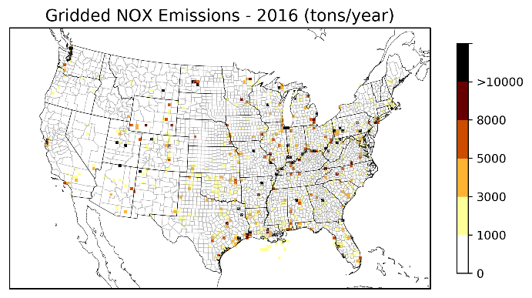 | 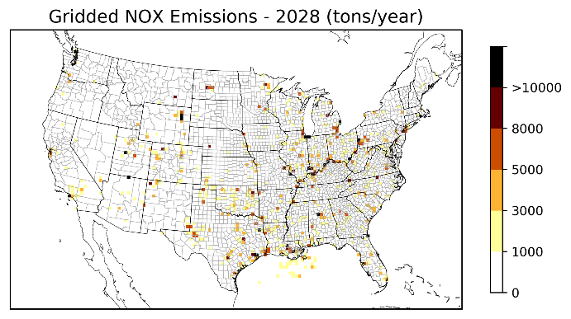
Figure 2-1. Annual point source NO_{x} emissions for the CenSARA for 2016 and 2028 in tons/year.
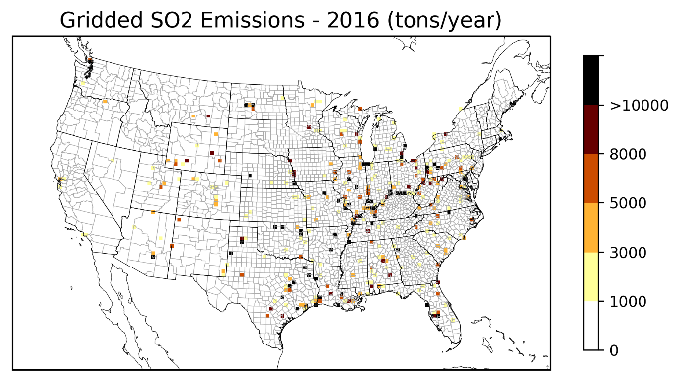 | 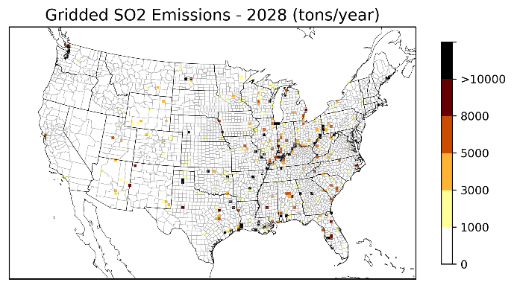
Figure 2-2. Annual point source SO₂ emissions for the CenSARA for 2016 and 2028 in tons/year.

Point Source Emissions Contributions
We examined source contributions from each facility to visibility impairment at each Class I area by matching the extinction weighted residence time (described in Section 2.3.3) with the facility-level emissions over distance of the 2016 and 2028 point source inventories. The resulting dataset is presented as Excel spreadsheets (provided separately) that contain the following information: Facility ID/Name, State/County/Federal Information Processing Standard (FIPS) code, North American Industry Classification System (NAICS) code, Industry description, SO₂/NOx emissions in tons per year (Q), Distance in km (d) between the facility center and each IMPROVE site, Q/d for SO₂/NOx, EWRT for SO₄/NO₃ and EWRT*(Q/d).

Graphic products
We prepared images of the residence time plots for each Class I area listed in Table 2-1 for all altitudes. We first mapped the back-trajectories to EPA’s 12 km continental U.S. (CONUS) domain, aggregated to 36-km resolution, and added image smoothing to reduce image noise. The images are centered around each IMPROVE site and include outlines of states and counties. This section presents examples for the residence time analysis described in Section 2 for the Caney Creek (CACR) Class I area located in Arkansas.
The interpretation of these results can be made qualitatively and quantitatively. The RHR has no specific guidance on threshold values for residence time. We chose a color scale that offers a reasonable range for normalized percentages across selected Class I areas and altitudes. As an aid to analysis, contour boundaries were added to identify regions with scaled residence time values greater than 0.05%, 0.1%, 0.2%, 0.5%, and 1%. States may select a specific cut-off (e.g., >0.5%) to identify Areas of Influence (AoI).
In the Caney Creek examples, the unweighted residence time plots (Figure 3-1) suggest influences from southerly air masses followed by northeasterly air masses on the 20% most impaired days in 2012-2016. The influencing air mass directions are evident in the distance-weighted residence time plots (Figure 3-2). The similarity of the unweighted (Figure 3-1) and the sulfate extinction-weighted (Figure 3-3) residence time plots imply that the 20% most impaired days are largely driven by high sulfate concentrations. Nonetheless, nitrate also contributes to visibility impairment at this site and is primarily associated with northwesterly and northeasterly air masses (Figure 3-4). The potential impact from SO₂ emission sources can be determined using the sulfate EWRT combined with distance-weighted SO₂ emissions displayed in Figure 3-5. Similarly, nitrate EWRT combined with distance-weighted NO_{x} emissions plots are shown Figure 3-6. Both types of figures include EWRT three contour boundaries (shown in green) to help define the SO₂ (or NOx) AoI as those areas with EWRT greater than 0.1% or 0.5%. For this specific site, the results using 100-m and 200-m end height are similar suggesting areas and sources near the monitor while the results using 500-m and 1000-m end heights also capture areas and sources further away.
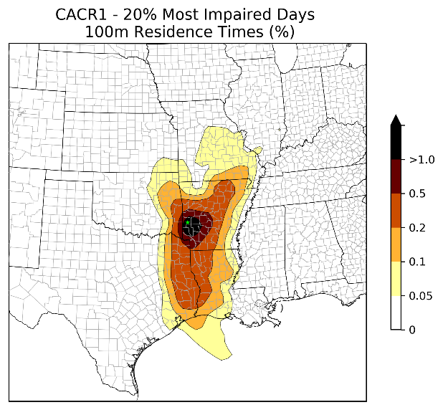 | 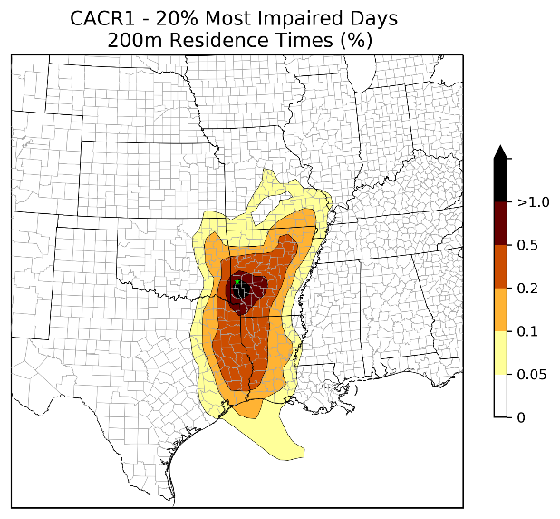
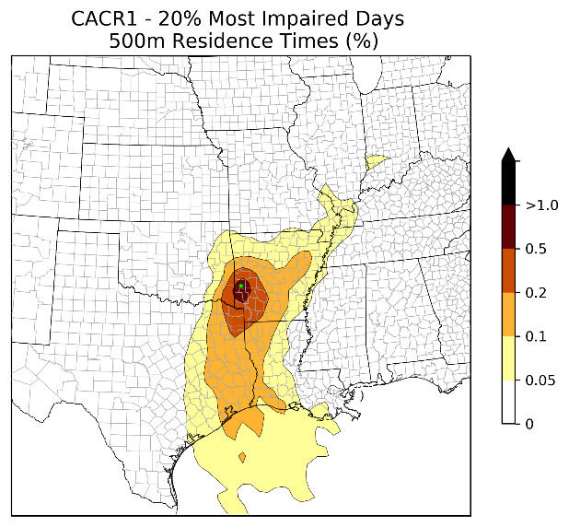 | 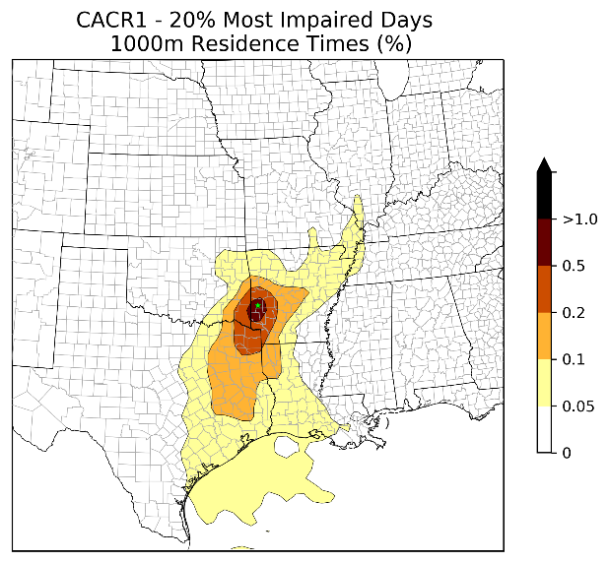
Figure 3-1. Example residence time plot for 20% worst visibility days in 2012-2016 for Caney Creek based on trajectories with 100-m, 200-m, 500-m, and 1,000-m end height.
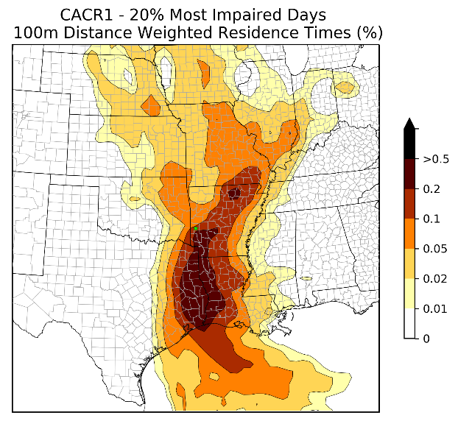 | 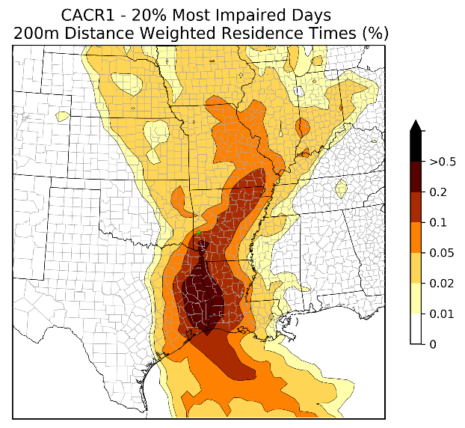
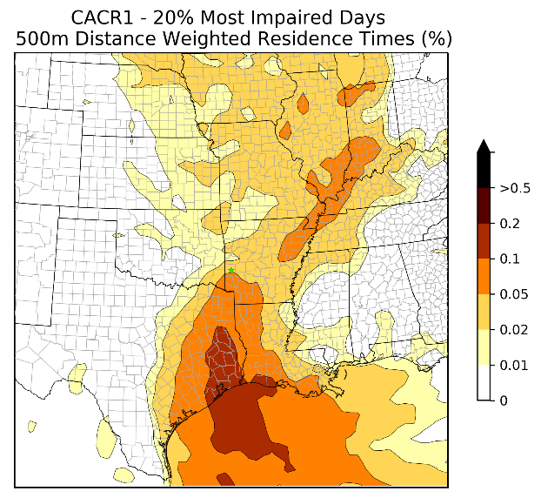 | 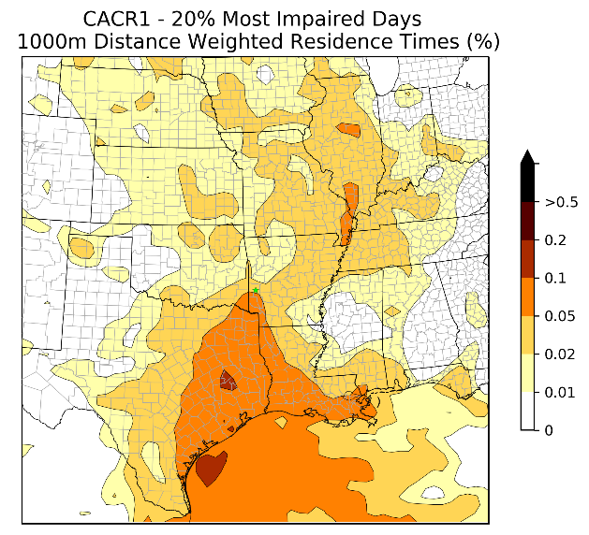
Figure 3-2. Example distance-weighted residence time plot for 20% worst visibility days in 2012-2016 for Caney Creek based on trajectories with 100-m, 200-m, 500-m, and 1,000-m end height.
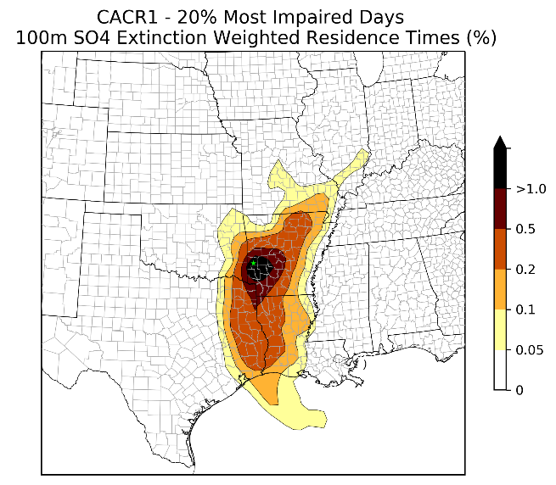 | 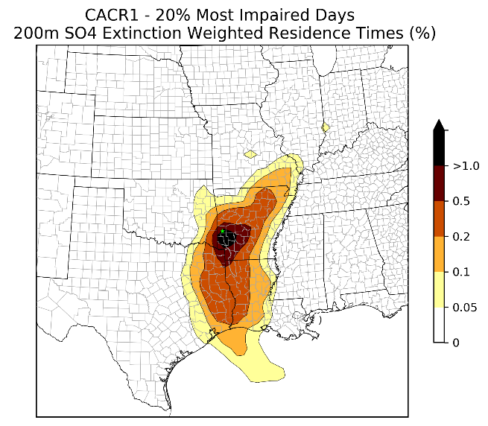
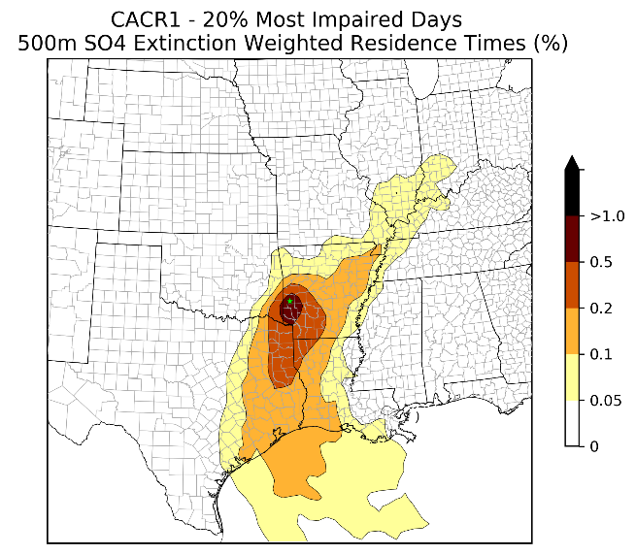 | 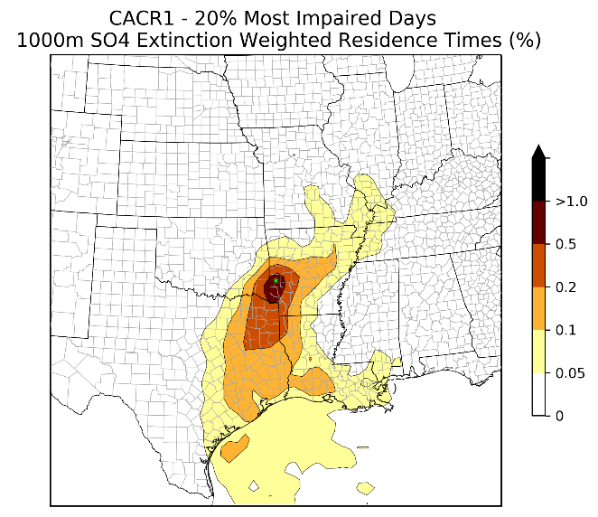
Figure 3-3. Example sulfate extinction-weighted residence time (EWRT) plot for 20% worst visibility days in 2012-2016 for Caney Creek based on trajectories with 100-m, 200-m, 500-m, and 1,000-m end height.
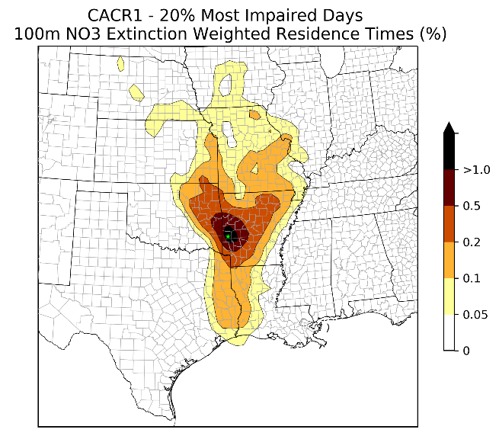 | 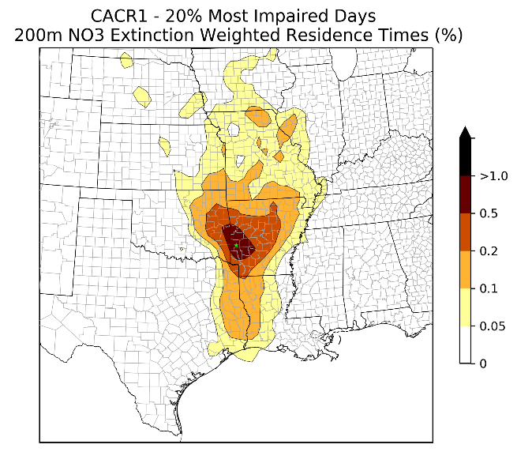
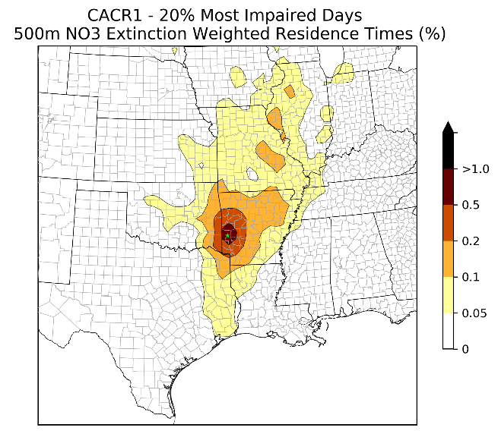 | 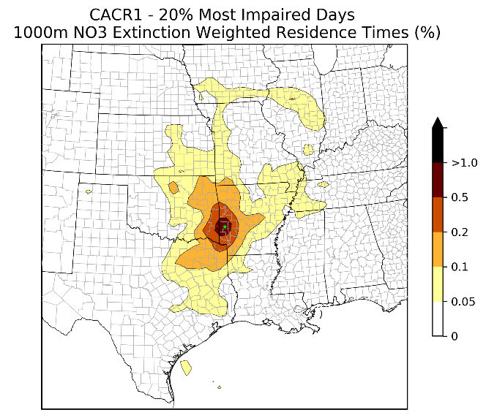
Figure 3-4. Example nitrate extinction-weighted residence time (EWRT) plot for 20% worst visibility days in 2012-2016 for Caney Creek based on trajectories with 100-m, 200-m, 500-m, and 1,000-m end height.
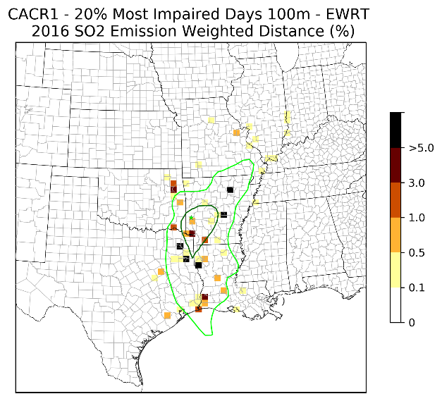 | 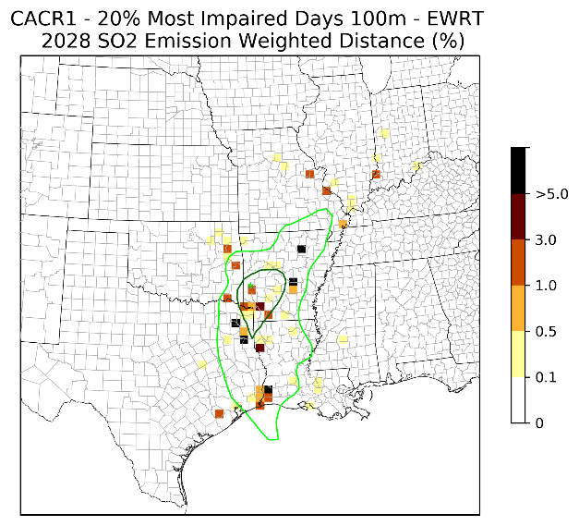
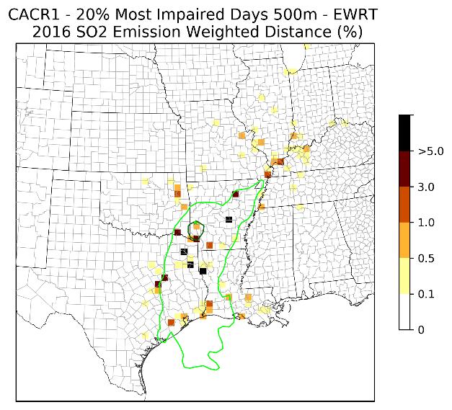 | 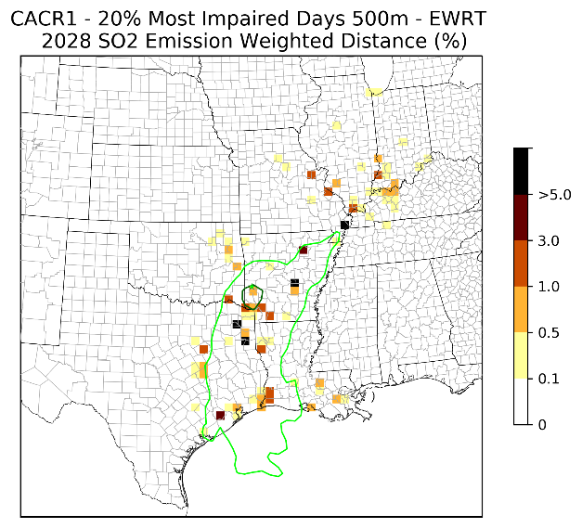
Figure 3-5. Example sulfate EWRT combined with distance-weighted (SO₂) emissions (2016 on the left and 2028 on the right) plot for 20% worst visibility days in 2012-2016 for Caney Creek based on trajectories with 100-m (top) and 500-m (bottom) end height. Contour boundaries based on the sulfate EWRT greater than 0.1% (lighter green) or 0.5% (darker green) are also shown.
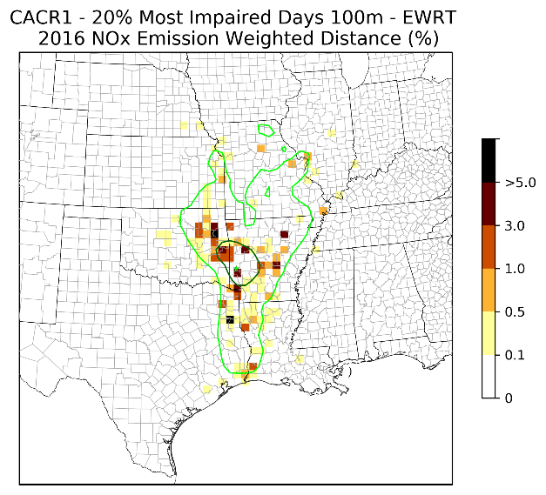 | 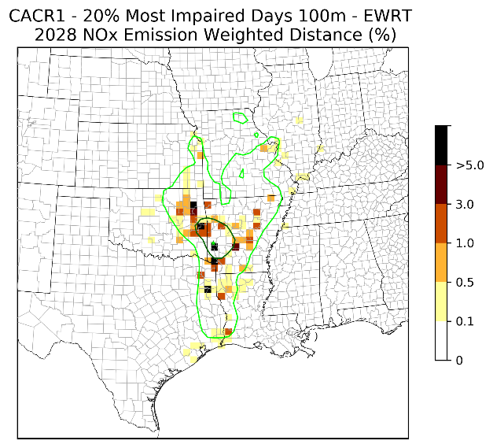
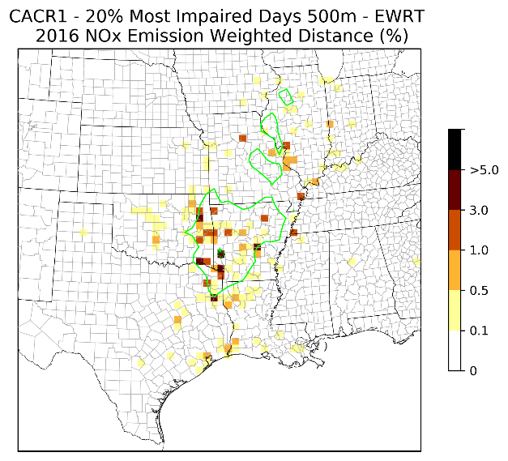 | 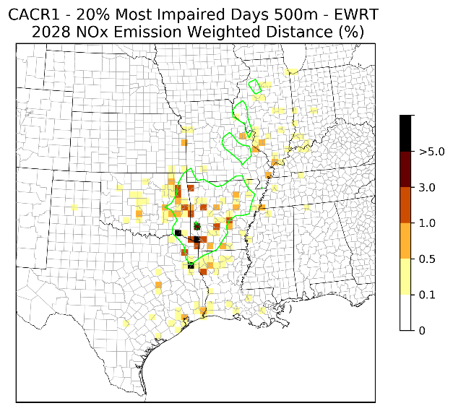
Figure 3-6. Example nitrate EWRT combined with distance-weighted (NO_{x}) emissions (2016 on the left and 2028 on the right) plot for 20% worst visibility days in 2012-2016 for Caney Creek based on trajectories with 100-m (top) and 500-m (bottom) end height. Contour boundaries based on the nitrate EWRT greater than 0.1% (lighter green) or 0.5% (darker green) are also shown.

Summary and Recommendations
In support of CenSARA’s Area of Influence (AoI) analysis, Ramboll generated HYSPLIT back trajectories for IMPROVE sites in CenSARA and neighboring states. Back trajectory analyses use interpolated measured or modeled meteorological fields to estimate the most likely central path of air masses that arrive at a receptor at a given time. Back trajectories account for the impact of wind direction and wind speed on delivery of emissions to the receptor, but do not account for chemical transformation and dispersion of emissions. We generated 72-hour back trajectories arriving at each of the IMPROVE sites at 06:00, 12:00, 18:00 and 24:00 local time for trajectory ending altitudes of 100 m, 200 m, 500 m, and 1,000 m.
Based on the five years of individual back trajectories on the most 20 percent impaired visibility days, we mapped trajectory paths into 36-km x 36-km horizontal grid cells and generated residence time data for each IMPROVE site. We then extended the analysis using emission, visibility extinction, and distance weighting approaches. States can use these values to further determine control strategy development for individual Class I areas.

Deliverables
Our deliverables in this project includes:

- A Final project report (this document)
- Images of the weighted and unweighted residence time for each Class I area (.png electronic format)
Excel Spreadsheets that show source contributions from each facility to visibility impairment at each Class I separately for the year 2016 and 2028

Uncertainties and limitations
Some of the uncertainties and limitations of the AoI analysis include:
- The choice of trajectory setup (i.e., ending time, ending altitudes, meteorology, vertical motion) affects the trajectories generated and the final AoI analysis. The gridded meteorological data file used for the HYSPLIT computation is a discrete representation of a continuous field. How the modeled representative of a nearby measurement depend upon local effects as well as the larger scale gradients of the variable and how well a gridded field can represent the underlying continuous field. The impact of receptor height (or end height) on an individual trajectory is also important. Low-ending trajectories represent air parcels nearer to ground level and high-ending trajectories may represent more accurate boundary layer flow above the local terrain.
- We quality assured the trajectory output by calculating the length of each 72-hour back trajectories (or maximum distance between each hourly trajectory segment and the trajectory endpoint) and examine if the distribution of trajectory lengths is reasonable (e.g., checking any obviously incorrect or unphysical trajectories). Some of the trajectory lengths at each 10-min timestep are longer than a 12-km grid cell (corresponding to wind speed of > 20 m/s), but they are occurring at higher altitudes that would be above mixing heights. These instances were deemed plausible so were not discarded.
- We adopted the latest emission estimates available. However, uncertainties related to emission inventories are expected, especially for the future year emission estimates. We did not evaluate uncertainty in the emission inventories used in this study.
- All residence time plots are displayed as relative values (i.e., percentage) based on all grid cells within the CONUS domain. The emission-weighted residence time plots account for EGU and non-EGU point emissions in the US, but they exclude emissions from non-point and international sources. Caution should be made when interpreting the emission-weighted results for Class I areas that are near the international borders, such as Big Bend (BIBE). The EWRT contour boundaries should be considered together with the emission-weighted values.
The back trajectories are based on a single air parcel transport pattern and does not fully account for three-dimensional transport and dispersion patterns and chemical transformation that can influence the transport and formation of visibility impairing particulate matter species.

Recommendations
Initial recommendations are as follows:
- Our results may be sensitive to the horizontal grid resolutions chosen (12 km x 12 km trajectories aggregated to 36 km x 36 km in the analysis). Further aggregation of horizontal grid cells (e.g., 50-km) may help tailor the presentations of the AoI to meet the CenSARA states’ needs.
Given that air parcels are expected to be exposed to emissions only when they are below mixing heights, the AoI analysis can be refined by excluding those trajectory segments that are above mixing height. HYSPLIT can optionally output mixing height estimates to facilitate this refinement.

References
EPA. 2015. 2011 National Emissions Inventory, version 3, Technical Support Document. U.S. Environmental Protection Agency, Research Triangle Park, NC. Aug. https://www.epa.gov/sites/production/files/2016-09/documents/2011v6_3_2017_emismod_tsd_aug2016_final.pdf)
Fleming, Z.L., Monks, P.S. and Manning, A.J., 2012. Untangling the influence of air-mass history in interpreting observed atmospheric composition. Atmospheric Research, 104, pp.1-39, https://www.sciencedirect.com/science/article/pii/S0169809511002948
Stein, A.F., Draxler, R.R, Rolph, G.D., Stunder, B.J.B., Cohen, M.D., and Ngan, F., (2015). NOAA's HYSPLIT atmospheric transport and dispersion modeling system, Bull. Amer. Meteor. Soc., 96, 2059-2077, http://dx.doi.org/10.1175/BAMS-D-14-00110.1

The Central States Air Resource Agencies Association (CenSARA) promotes the exchange of information related to air quality among states, tribes, local and federal agencies and others and includes the states of Arkansas, Iowa, Kansas, Louisiana, Missouri, Nebraska, Oklahoma and Texas.
The Round 2 regional haze rule SIP baseline is 2013-2017. However, the IMPROVE most anthropogenically impaired days data for 2017 are not yet available, so 2012-2016 will be used.
https://www3.epa.gov/ttnamti1/files/ambient/visible/tracking.pdf
http://vista.cira.colostate.edu/Improve/rhr-summary-data/
Note change in monitor location from planning period 1 – previously BRET1, now BRIS1
https://www.epa.gov/air-emissions-modeling/2011-version-63-platform
https://www.wrapair2.org/pdf/2017-12-12_2016%20Emissions%20Modeling%20Platform%20Development%20Plan_V1.0.pdf
ftp://newftp.epa.gov/air/emismod/2016/alpha/2016fd/emissions/
Our Quality Assurance Project Plan (QAPP) proposed using the 2011 NEI modeling case 2017ek for non-EGU sources. After consulting with CenSARA, the 2016NEI alpha inventory is deemed more representative of the 2016 conditions.
https://ready.arl.noaa.gov/archives.php
http://www.nco.ncep.noaa.gov/pmb/products/nam/
ftp://arlftp.arlhq.noaa.gov/nams
Trajectories ending on the following days used NAM 3-houlry data obtained from ftp://arlftp.arlhq.noaa.gov/pub/archives/nam12 as the NAMS data was missing: 07/26/2012, 07/27/2012, 01/12/2015, 01/13/2015, 01/15/2015 and 01/16/2015.
$d_{ij}$ is calculated in meters in the Lambert conformal conic projection
https://www.epa.gov/sites/production/files/2016-07/documents/technical_support_document_for_draft_guidance_on_regional_haze.pdf
12US2 domain has a lower-left corner at (-2412000 m., -1620000 m.) and 396x246 grid cells. Projection is Lambert-Conformal, with Alpha = 33º, Beta = 45º and Gamma = -97º, with a center of X = -97º and Y = 40º.
Based on Gaussian Filter, https://docs.scipy.org/doc/scipy/reference/generated/scipy.ndimage.gaussian_filter.html

