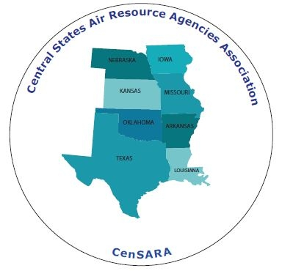

CenSARA Fall Business Meeting 2017
October 10-12, 2017

The Chase Park Plaza
212 N. Kingshighway Blvd.
St. Louis, Missouri 63108

Reservations may be made by calling:
877-587-2427 or 314-633-3000
The reservation group name is “CENSARA”
Reservations may also be made directly online by clicking this link: CenSARA Fall Meeting 2017
Or going to www.chaseparkplaza.com and using group code:11A3RZ

*Please note that the cutoff date for CenSARA’s group reservation block is Saturday, September 9^{th,} 2017. However, group rates ($125.00 per night/Gov Rate) will be honored up to three days prior to the event based upon availability.
For help with travel assistance, issues with booking or general questions, please contact
DeAnna Scofield at dscofield@censara.org or 405-813-4303.

