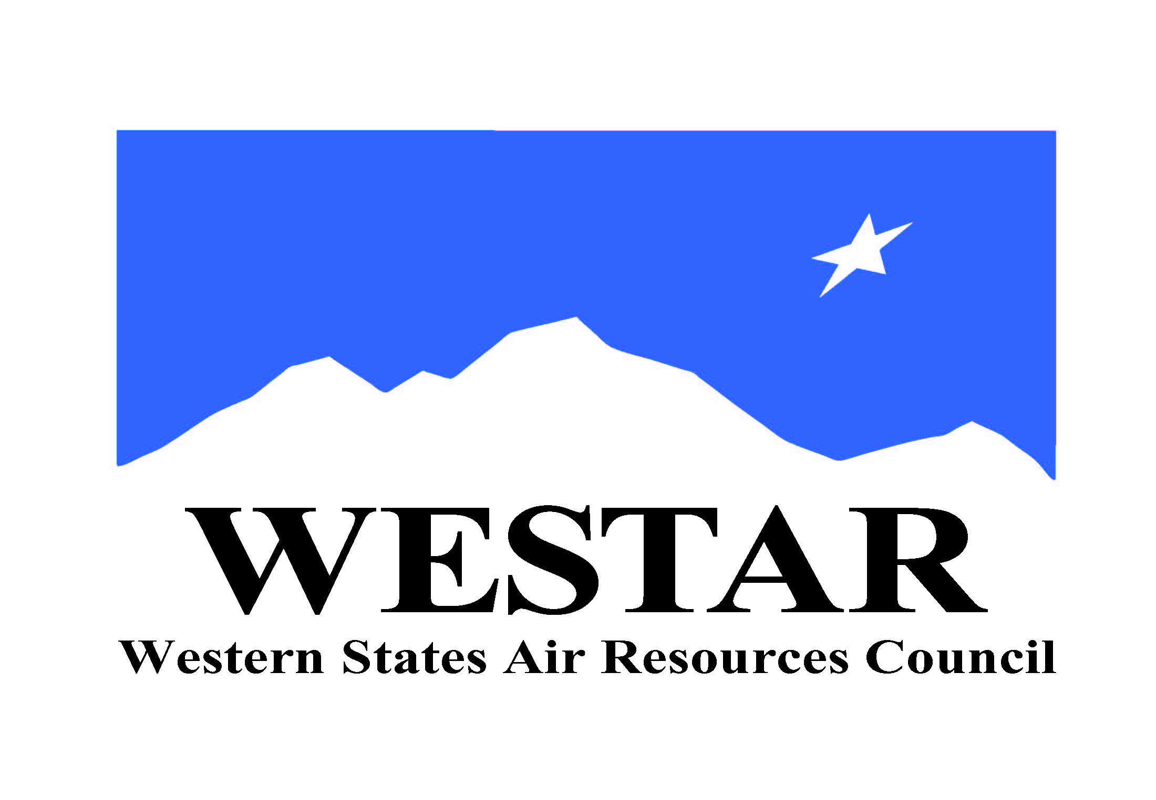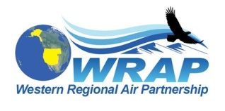

DRAFT 9/22/17

Round 2 Regional Haze Workshop

State Planning, Regional Analysis, and National Coordination
December 5 – 7, 2017

Registration: https://westar.ticketleap.com/westar-regional-haze-planning-workshop/

Meeting & Lodging Information: Remote Access Information:
Westin Downtown Phone: to be added
xxxxx Access Code: to be added
Denver, CO Go-To-Meeting: to be added
Phone (303) xxx-xxxx

Workshop Objectives:

- Review previous Regional Haze planning experiences / lessons learned (optional);
- Clarify states’ planning needs and responsibilities;
- Discuss state-provided inputs to regional analysis activities;
- Identify coordination needs within and across regional analyses;
- Assess national data inputs for state planning purposes; and
- Prepare timelines for work products.

Participants

- WESTAR-WRAP states’ Regional Haze Planners
- WRAP Technical Steering Committee
- WRAP Work Groups’ Co-Chairs and interested members of Work Groups
- EPA western Regional Office planners and analysts, national offices’ program leads
- FLM leads on planning and analysis
- WESTAR-WRAP staff, representatives of states in other regional organizations outside the West
- selected technical contractor support staff

Tuesday December 5th (optional, main workshop starts Wed. December 6th)
Input from CenSARA states is a preference to learn about roles of the RPOs, overview of EI and modeling processes from the first round of SIPs, and lessons learned Some of the names mentioned as participants were Ryan Templeton (AZ), Jim Price (TX), Scott Copeland, Jeff Underhill (Mane-Vu) Donna or Zac (LADCO). I’ve asked Jim if he was attending/available.

1:00 PM Informational background session on Regional Haze analysis and planning (Tom Moore to coordinate)

3:00 Break

3:15 Background session, continued

5:00 Adjourn for the day

6:00 No Host dinner - location to be announced

Wednesday December 6th (main workshop)

8:00 AM Welcome, Agenda Review, and Workshop Objectives (Mary Uhl, other Regional Org leads)

8:15 Overview of Round 2 Regional Haze analysis and planning for July 2021 SIP due date (Tom Moore, others?)

8:45 Examples of analyzing and applying IMPROVE data and Natural Conditions for Round 2 Regional Haze planning (session organizer TBD)
CenSARA states feel it’s important to review again the phase 1 SIPs equation and what’s in EPA’s draft guidance as well as any individual regions that may have decided on different equations and discuss if there is common ground on what to use for phase 2… good to also hear what OTC/MANE-VU did.

- WESTAR-WRAP states’ Regional Haze Planners (2)
- Central and Eastern states’ Regional Haze Planners (2)
- EPA Regional Office or IMPROVE rep (1)

10:00 Break

10:15 Round 2 Analysis Base Year(s) Emissions Data (panel discussion, overview, session organizer TBD)
TP thought – each MJO surveys its states before the workshop about best year(s) to use, then summarize in a handout for discussion and/or status of the work the 2016 modeling platform workgroups are doing. Also need to hear from OTC/MANE-VU Allison Eichs? To be session chair. Maybe Pat Brewer on the panel. Is a 2016 inventory approach viable when data won’t be available til summer 2018 (projecting to 2028)

- WESTAR-WRAP, CenSARA, LADCO, SESARM, MANE-VU regions (up to 5)
- National EPA program leads (1-2)

12:00 PM Lunch (on your own)

1:00 Uncontrollable Visibility Impairment Sources in Round 2 Analysis and Planning – Mobile, Marine Shipping, Fire and Smoke, Dust / other Natural U.S. emissions, and International Emissions (topical presentations and discussion, session organizer TBD)
Texas is interested in participating on this panel (intl emissions interest) This session is morphing just a bit. Tina? Will be the session chair. Discussion on having Ralph Morris on the panel. Likely won’t need TCEQ on the panel but definitely they can contribute to discussions.

- 3-4 speakers from among WESTAR-WRAP, CenSARA, LADCO, SESARM, MANE-VU regions, National EPA program leads

2:30 Break

2:45 Projecting “rules-on-the-books” and other changes in emissions for 2028 Reasonable Progress modeling (topical presentations and discussion, session organizer TBD)
TP – have EPA review what they have/plan to include in any technical work they do. Maybe RPOs include question to states with base year survey to see if there are any state-specific measures that should be included – ex: Round 1 and 2 SO2 SIPs Can we get EPA to speak to the timing issues, and Mane-Vu /OTC staff will definitely be part of the discussions.

- 3-4 speakers from among WESTAR-WRAP, CenSARA, LADCO, SESARM, MANE-VU regions, National EPA program leads

4:00 4-Factor Analysis and Linkages to setting Reasonable Progress Goals (presentation of examples and discussion, session organizer TBD)
CenSARA input – possible look back at how five factor analyses were completed and what might be carried over to a four factor analysis.. any state/RPO that is doing 4 factor analysis or plans to do one could participate on panel. What did OTC/MANE-VU do? Someone from WESTAR, Randy from NC suggested discussion on determining the area of influence around the Class 1 areas. Maybe Jim Boyland, someone from Mane-Vu…Jeff discussed having some way to lay out information without them monopolizing every session! Maybe they will handle some of these remotely to allow other Mane-Vu staff to participate.

- 3 speakers from among WESTAR-WRAP, CenSARA, LADCO, SESARM, MANE-VU regions, western EPA Regional Offices

5:00 Adjourn for the day

6:00 No Host dinner - location to be announced

Thursday December 7th (main workshop followed by afternoon caucus sessions)

8:00 AM Agenda Review (Mary Uhl, other Regional Org leads)

8:15 Application and Coordination of regional modeling for haze SIPs (Tom Moore, others to organize? -panel discussion, overview)
CenSARA will most likely be in the listen mode for this panel…Pat Brewer as a panelist,

- Status and uses of EPA national modeling platform results (1)
- WESTAR-WRAP, CenSARA, LADCO, SESARM, MANE-VU regions (up t 5)

9:45 Break

10:00 Applying regional modeling results for setting Reasonable Progress Goals (session organizer TBD)

10:45 Communication and outreach on Regional Haze planning (session organizer TBD)
CenSARA – is session to be about consultation requirement with FLMs and states or what different states are planning for stakeholder processes. OTC/MANE0VU needs to explain their consultation process they’re going through now….Look for this to be fleshed out as well as some of the timing for this day to shift.

11:45 WRAP-up and Next Steps (Tom Moore, others?)

12:00 Adjourn Workshop, lunch on your own

1:00 Western State Caucus, other separate breakout meetings as needed

3:00 Adjourn caucus / other meetings and homeward bound

