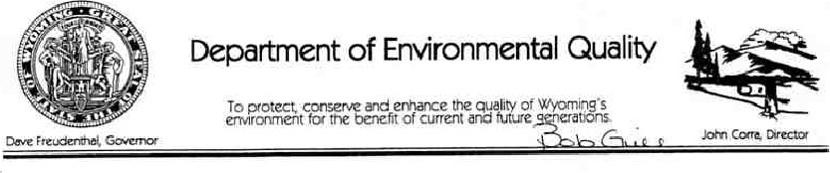
January 5, 2006
Mr. Steve Legg
Industrial Hygi ene!Safety Manager US D artment of Veterans Affairs 2360 Blvd.
82001
RE; Notice of Violation
Dear Mr. Legg:
Enclosed you will find a Notice ofViolation (NOV) issued to the US Department of Veterans Affairs by the Department of Environmental Quality, Air Quality Division, for the failure to comply with air &uality permitting and regulatory reporting requirements for the boilers at the Cheyenne Medical
As the Department and this Division consider the failure to comply with air quality permitting and regulatory requirements to be a serious matter, am considering recommending the Department refer this violation to the State Attorney General '5 office requesting a suit be filed in District Court to recover appropriate penalties. If you would like to discuss settlement of this Notice of VioIation prior to referral to the Attorney General's office, please contact Mr. Robert Gill, Air Quality Compliance Program Manager, at 307-777-3774 no later than ten ( 10) day5 after receipt of this
Shou Id you have any questions or comments regarding this matter, please feel free to contact m e or Mr. Robert Gill.
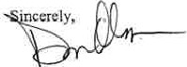
Dan Olson
Administrator Air Quality Division
cc; Bemie Dail
Gl enn S an er
Nancy ehr

BEFORE THE
DEPARTMENT OF ENVIRONMENTAL QUALITY STATE OF WYOMING
IN THE MATTER OFTHE NOTICE OF VIOLATION
ISSUED TO THE US DEPARTMENT OF VETERANSDOCKET NO.
AFFAIRS, MR. STEVE LEGG, INDUSTRIAL HYGIENE/
SAFETY MANAGER, 2360 E. PERSHING BLVD.,3835-06
CHEYENNE, WYOMING 82001
NOTICE OF VIOLATION
NOTICE IS HEREBY GIVEN THAT:
l, The Department Of Environmental Quality, Division of Air Quality, has found the US Department Of Veterans Affairs to be in violation Of W.S. 35-11 -SO I of
the Wyoming Environmental
Quality Act, Chapter 6, Section 2 of the Wyoming Air Quality Standards and Regulations and Chapter 5, Section 2 of the Wyoming Air Quality Standards and Regulations in the construction and operation of the new boilers at the Cheyenne Medical Center located in Laramie County, Wyoming.
- W.S. 35-11-801(e) states, ••A permit to Construct is required before the construction or modification of any industrial facility capable of causing or increasing air or water pollution in excess Of standards established by the department is commenced."
- Chapter 6, Section 2 Of the Wyoming Air Quality Standards and Regulations prescribes the applicability and procedures for issuing permits to sources under Wyoming's construction and modification permitting program.
- Chapter 6, Section Of the Wyoming Air Quality Standards and Regulations States, "Any person who plans to construct any new facility or Source. modify any existing facility or source. or to engage in the use of which may cause the issuance of or an increase in the issuance of air contaminants Into the air of this state shall obtain a construction permit from the State of Wyoming. Department of Environmental Quality, before any actual work is begun On the facility."
- Chapter 5, Section 2 of the Wyoming Air Quality Standards and Regulations adopted 40
CFR Part 60, Subpart Dc by reference. 40 CFR Part 60, Subpart Dc (Standards of
Performance for Small Industrial-Commercial-institutional Steam Generating Units) establishes emission limits, monitoring, record keeping and reporting requirements for steam generating units with a heat input capacity of 10 million to 100 million BTU per hour, 40 CFR Part 60, 560.42c(d) establishes S02 emission limits for oil fired steam generating units and "60.4Sc(d), 60.48c(e), 60.48c(t), 60.48c(g), 60.4Sc(i) and 60.48c(j) establish the associated monitoring, record keeping and reporting requirements which apply to these boilers.
- On September 29. 2005, Mr. Glenn Spangler, State of Wyoming Air Quality Division Compliance Inspector, and Ms. Cindy Beeler, US EPA Region VILI State Coordinator, conducted an inspection of the Cheyenne Medical Center. During the inspection, Mr. Spangler and Ms. Beeler noted that the Cheyenne Medical Center install three new boilers (two with a heat input capacity 10.5 MMBTLJfhr and one with a heat input capacity of4.2 MMBTU/hr) which have the capabi lity to fire on natural gas and distillate oil. A review ofavailable records indicates that the Cheyenne Medical Center did not obtain an air quality permit for these boilers and did not comply with any reporting requirements Of 40 CFR Part 60, Subpart Dc.
- Said violations consist of
- the failureto complywith the air quality permitting requirements

Notice ofViolåtion
US Department Of Veterans Affairs Page 2
prior to Commencing construction and operation of the boilers at the Cheyenne Medical Center in Violation of W.S. 35- I I-SOI of the Wyoming Environmental Quality Act and Chapter 6, Section of the Wyoming Air Quality Standards and Regulations and the failure to comply with the reporting requirements for the two boilers with a heat Input capacity of 10.5 million BTU/hour in violation of Chapter 5, Section 2 of the Wyoming Air Quality Standards and Regulations (40 CFR part 60, Subpart Dc by reference).
S. Under W.S. 35-11-901(a), any person who violates any provision of Article 2 of [the Environmental Quality Acq , or any rule, regulation, standard or permit adopted pursuant to those provisions, or who violates any determination or order oflhe council pursuant to Afticle 2 of [the Environmental Quality Act] is subject to a penalty not to exceed ten thousand dollars (S 10,000.00) for each violation for each day during which the violation continues, a temporary or permanent injunction. or both a penalty and an injunction.
9. This noticeis being sent to you pursuantto W.S. 35-11•701 (c), which requires that, in any case of the failure 10 correct or remedy an alleged violation, the Director of the Department Of Environmental Qualityshall cause a written notice to be issued and served upon the person alleged to be responsible.
DATED this ——7174— day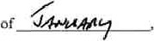2006.
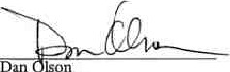
Administrator
Air Quality Division
. Corra
tor ent o f Environmental Quality
Please direct all inquiries to Dan Olson, Administrator, Division of Air Quality. Department of
Environmental Quality, Hersehler Building, 4th Floor, 122 W. 25th Street, Cheyenne, Wyoming 82002. (Telephone: 307/777-7393.)

