
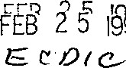
UNITED STATES ENVIRONMENTAL PROTECTION AGENCY

WASHINGTON, D.C. 20460

OFFCE OF ENFORCEMENT

MEMORANDUM
SUBJECT : Model Notice of Violation
FROM : Michael S. Alushin" L....z—:— Associate Enforcement Counsel
TO: Regional Counsels
Regions
Regional Air Division. Directors
Region I—X
The attached is . an interim draft model notice of violation
( "NOV") , that includes changes and additions from the Clean Air Act Amendments. NOVs being issued should now reflect the fact that there is no continuing violation requirement and that the source may have the burden in an enforcement proceeding to prove compliance after the date of the notice. This model can be adapted to the particular format already . in use in the Region. Please use this model on an interim basis to accomodate changes which are presently effective under the. Clean Air Act Amendments.
The use of the language describing the presumption • of' noncompliance is not limited to NOVs for SIP violations . Section 113 (e) (2) ^{e}, for purposes of determining the number o: . days of violation, allows EPA to benefit from a presumption of a continuinq:. violation "where the Administrator or an air pollu€ion control agency has notified the source of the- violation. . . " Thus, se±fon 113 (e) (2) also presents the opportunity for the Agency. this presumption in administrative orders or finding. - violation notices. An order or a document containing a finding of violation by the Agency constitutes "notice" such that from the date of the document's issuance, the presumption of noncompliance begins to run and a source can be cons idered to be in violation until it establishes continuous compliance.
Because the presumption exists only where EPA "makes a prima facie showing that. the conduct or events giving rise to the violation are likely to have continued or recurred past the date of notice. . . " the Region should be aware that, at some point, a
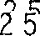1559
Printed an Recycled Pacer
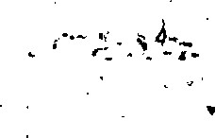

-2-
demonstration that the violation is continuing or recurring in nature will be. required. An order should include language, like that in the NOV, ndtifYing the source that. EPA considers the source to be in .violation until it establishes continuous compliance . It should also inclUde the "Penalty Assessment section from the NOV that contains the language creating a presumption of noncompliance.
This model can be used now, though language regarding administrative penalty orders should only be used after the implementing Part 22 hearing procedures are promulgated. Promulgation is expected by September, - 1991.
Please submit comments on this draft to Alexandra Call am by April 1, 1991. In •addition, please let me know of any developing cases that could serve as a test of the new •presumptiof'l' of noncompliance, i.e. cases that have favorable 'facts for determining the extent to which EPA must show that a. violation is continuing ^{K}and for determining the' nature of defendånt's burden to prove compliance. We are available to assist you with the initial cases where the issue is presented.
Attachment
cc: Regional Counsel 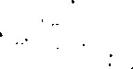
Air Contacts
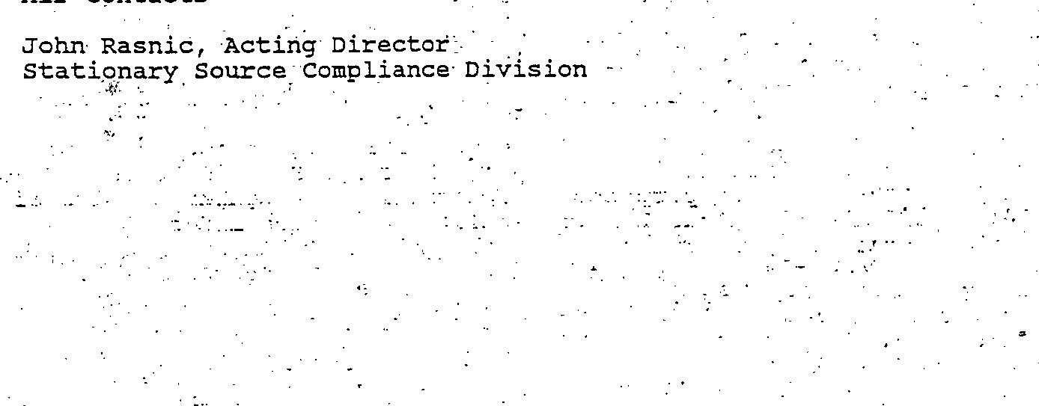
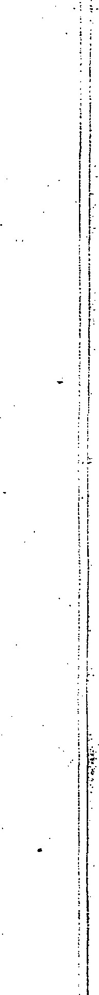
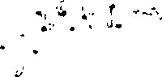
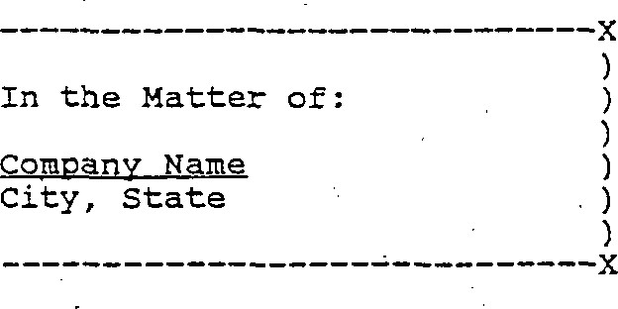
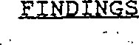
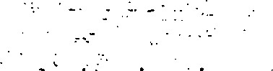
MODEL NOTICE OF VIOLATION
UNITED STATES ENVIRONMENTAL PROTECTION AGENCY

REGION
Notice Of Violation Index No '000000

STATUTORY AUTHORITY

THIS NOTICE OF V101ÆT10N (NOV.) is issued to Company Name
( "Respondent"), for violations at its 'facility located at Company
Address, pursuant to Section 113 (a) (1) of the Clean Air. Act¯ (the
Act) , 42 U.S. C. • Section 7413.(a) (1) , as amended on November 15, 1990 by P. L. 101-549 '. Section 113 (a) (l) requires the
Administrator of the United States Environmental . Protection Agency (EPA) to notify a person in violation of a state implementation plan or permit of the violation. The authority to issue NOVs has been delegated to the Division Branch EPA, Region
1. The state administrative code, Section 010, provides that no person shall cause, suffer, allow; or permit volatile organic compounds ( *' ^{I}VOC" ) to be emitted into the outdoor atmosphere .from a source operation under Section 020, in excess of' the emission rate-• as determined in accordance with.nable 030 .
- . Sect*on 010 is a part of the„ federally—approved and federally.—enforceable state implementation plan (see 40 CFR
- . Company name manufactures drugs and vitamins incapsules. . name uses a granulation d.rying process to. evaporate used in washing the capsules. The drying oven used by Respondent is a source operation listed under section 020.
- . On duly authorized EPA inspectors conducted an unannounced inspection of. the s;qrupany name facilities. at address. in accordance with. Section 114 of the Act. The inspectors observed the operation of the drying oven and found that there were no devices to control the VOC emissions from. the drying oven ..
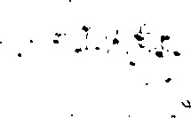
5 . on date, EPA performed a stack test to measure the emissions from the drying oven to the outside atmosphere. The results of Sie stack test showed that the drying oven emitted solvent at euission rate.
Infor-mation provided by company name to the EPA pursuant to a Section 114 information request indicates that Respondent operates the drying oven at full capacity 14 hours per day, 6 days per week.
7'. Under section 010, the allowable emission rate for Respondent's drying oven, as determined by Table 030, is emission
r.ate. Respondent emits % # in excess of allowable eraission r.ate.
8 . Therefore, Respondent is in violation, and is considered to be in violation until it establishes continuous compliance, of state .ad.ministrative code, Section 010 . [Respondent has been in violation of state administrative • cöde, Section 010 since date. (Use if there are facts indicating the date. noncompliance • began prior to NOV issuance..) ]

ENFORCEMENT
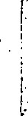
Section 113 (a) (1) of the Act provides that at ahy time after the expiration of 30 days following the date. of the issuance of this Notice, the Regional Administrator (delegated?) may, without regard to the period of violation,
—issue an order requiring compliance with the requirements of the state implementation plan or penit, • or •
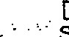
—issue an administrative penalty order- pursuant. to: section 113(d)• •for civil administrative penalties •of up to $25 , 000 per day of violation] • (to be used after ad.ministrative penalty •regulations a-re issued) ,

—bring a. civil action pursuant to seetion 113 (b) for injunctive relief and/or civil penalties of' not more than .$25, 000 per day for each violation.
Furthermore, for any person who knowingly viölates any plan or permit requirement more than 30 days after' the date of the issuance of thiS Notice, Section 113 (c) provides for • criminal penalties or imprisonment, or both.
In addition, under Section 306 (a) , the regulations promulgated thereunder (40 CFR Part .15) , and Executive Order 11738, facilities to be utilized in• federal •contracts', grants and loans must be in full compliance with the Act • and a IL % regulations
promulgated pursuant thereto. violation of the Act may result
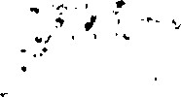
the subject facility being declared ineligible for participation in any federal contract, grant, or loan.

PENBLTX ASSESSMENT CRITERIA
section 113 (e) (1) of the Act states that the court, as appropriate, shall, in determining the amount of penalty' to be assessed, . take into consideration (in addition to such other factors as justice may require) the size of the business, the economic. impact of the penalty on the business, the violator's full compliance history and good faith efforts to comply, the duration of the violation as established by any credible evidence ( including evidence other than . the applicable test method) ; pay-ment by the violator of penalties previously assessed for the salae violation, the economic benefit of noncompliance, and the seriousness of the violation.
Section 113 (e) (2) of the Act allows the court to assess a penalty for each day of violation. For purposes of determining the number of days of violation; •where
r..elevant air: pollution cont;r.pl agency) makes a, prima facie showing that the• conduct or events giving rise to this violation are likely to have continued or recurred past the date of this NOV (or a previously issued air pollution control agency NOV for . the same violation) , the days of violation shall be presumed to include the date of this NOV (or the previous NOV) and each and every day thereafter until Respondent establishes that continuous compliance has been achieved, except to the extent that Respondent can prove by the preponderance of the evidence that there were intervening days during which no violation occurred or that the violation was not continuing in nature.

OPPOR'.WNIT{ FOR CONFERENCE
Respondent may, upon request, confer with EPA. The conference vill enable Respondent to present evidence bearing on the finding of violation, on the nature of violation, and on any 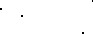efforts it may have taken om proposes to • take to achieve compliance. : Respondent has the •right: •to be • represented by counsel. A request for a conference must be made within days
of receipt of this NOV. The request for a conferenee or other inquiries concerning the NOV should be made in vmiting to
ORC Attorney
This NOV shall be effective immediately upon receipt'.

